Security Challenges in Committing TFState to GIT
In organisation, multiple team members will work on TF. So If you store your TF code in your internal if any disaster happens the whole code will be lost. To avoid this we will push our code to remote repo’s like github, bitbucket etc.
Now, you pushed your code to remote repo, but if it’s having some passwords it will be exposed to whole team members. We must avoid pushing password related codes to remote repo.
Eg: Below script is for RDS. You can see it’s having password “mysecretpassword505”
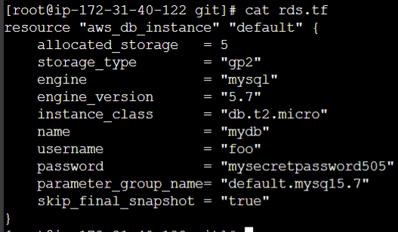
To overcome that, many of them do interpolation. It’s nothing but storing the password in a file outside of the git repo and providing the path of the file in the code. The password file will appear here.
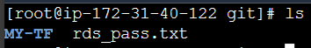
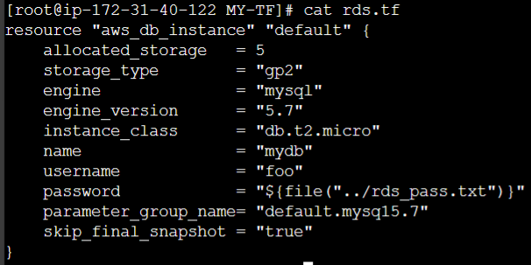
So they will use like in above model. But this way also not the secured way. Because during “terraform plan” and “terraform apply” it will show as sensitive value.
After running “terraform apply” the “tfstatefile” will be created so they will push it to git repo. But this can be ignored through ‘.gitignore’. Anyway this not a recommended way to store and secure the password.
Terraform Module Sources
The source argument in a module block tells terraform where to find the source code for the desired child module.
- Local paths
- Terraform Registry
- GitHub
- Bitbucket
- Generic git, Mercurial repos
- HTTP URLs
- S3 buckets
- GCS buckets
Local Path
A local path must begin with either ./ or ../ to indicate that a local path is intended.
module “consul” {
source = “../consul”
}
Git module Source:
Arbitrary Git repos can be used by prefixing the address with the special “git::” prefix.
After the prefix, any vaild Git URL can be specified to select one of the protocols supported by Git.
module “vpc” {
source = “git::https://example.com/vpc.git”
}
module “storage” {
source = “git::ssh://username@example.com/storage.git”
}
By default, Tf will clone and use the default branch (referenced by HEAD) in the selected repo.
You can override this using the ref argument:
Module “vpc” {
Source = “git::https://example.com/vpc.git?ref=development”
}
The value of the ref argument can be any reference that would be accepted by the git checkout command, including branch and tag names. Here the branch name is development we have to add extra after the repo url “?ref=development”. So it will fetch the development branch file.
Gitignore
Depending on the environments, it is recommended to avoid committing certain files to GIT.
Files to Ignore | Description
.terraform | This file will be recreated when terraform init is run.
Terraform.tfvars | Likely to contain sensitive data like usernames/passwords and secrets.
Terraform.tfstate | Should be stored in the remote side
Crash.log | If terraform crashes, the logs are stored to file named crash.log

Create a .gitignore file and the files which are not required like below.
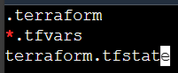
Terraform Backend
Backend primarily determine where terraform stores it state.
By default, Terraform implicitly uses a backend called local to store state as a local file on disk. The terraform.tfstate file will be stored in the same path. But this is not the best way in larger organizations.
Challenges:
Nowadays TF project is handled and collaborated by an entire team.
Storing the state file in the local laptop will not allow collaboration. Storing in github also creates an issue.
Ideal architecture:
Following describes one of the recommended architectures:
- The TF code in Git repo.
- The state file is store in a central backend.
So, you have a central git repo for your TF code and you have central backend for your state file.
Backend supported in TF:
TF supports multiple backends that allows remote service related operations.
Some of the poular backends include:
- S3
- Consul
- Azurerm
- Kubernetes
- HTTP
- ETCD
As per your backend requirement you need to configure each one of it in it’s own way.
Here we are using S3. Before going to do practical, let’s see an important note.
Important note:
While you are accessing the state file in local it doesn’t require any access but in a remote service generally requires some kind of access credentials.
Some backends act like plain “remote disks” for state files; others support locking the state while operations being performed, which helps prevent conflicts and inconsistencies.
Eg: Let’s assume you have terraform state file present in S3 bucket When you want to access it you need access secret key.

Hands on: I have created a new S3 bucket with the name “tfs3bucket”, Inside that bucket create a folder with the name of “network”. Like that you can create a multilple folders for each team’s activity like “security”.
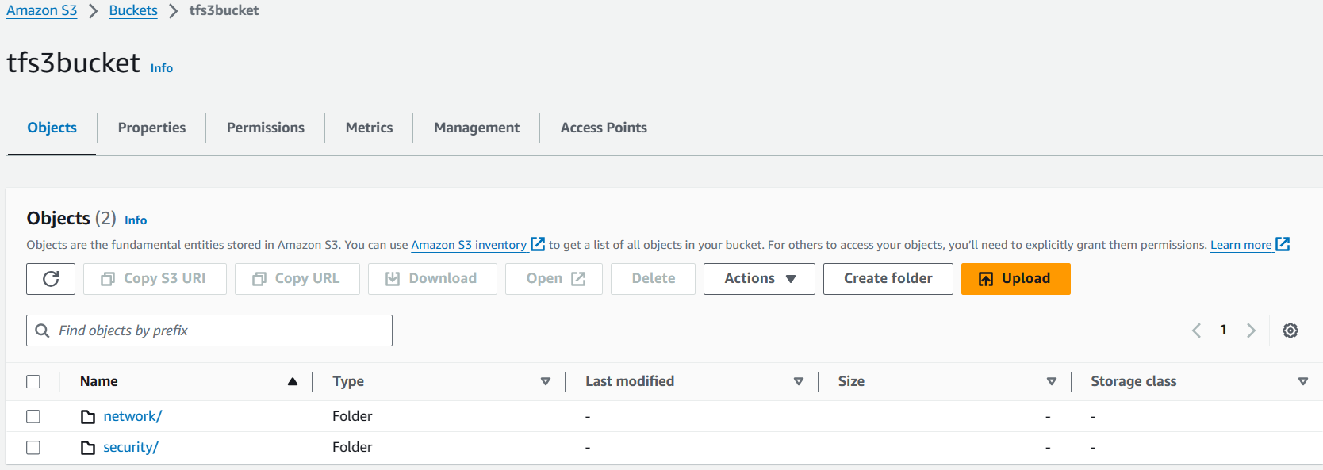
Now go to CLI create a file with the name of ‘backend.tf’ and write below script.
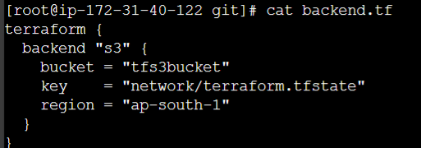
Now next step is authentication and authorization of S3 bucket. Atleast we need put and get permissions. For that we need AWS CLI, once it’s there we need to run “aws configure” command.
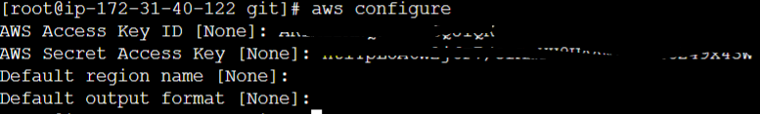
To check the access run “aws s3 ls s3://tfs3bucket”.
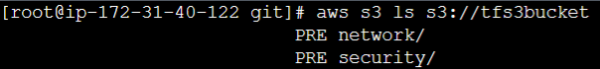
Now run the “terraform plan -auto-approve” the state file will be stored in network folder inside s3 bucket.
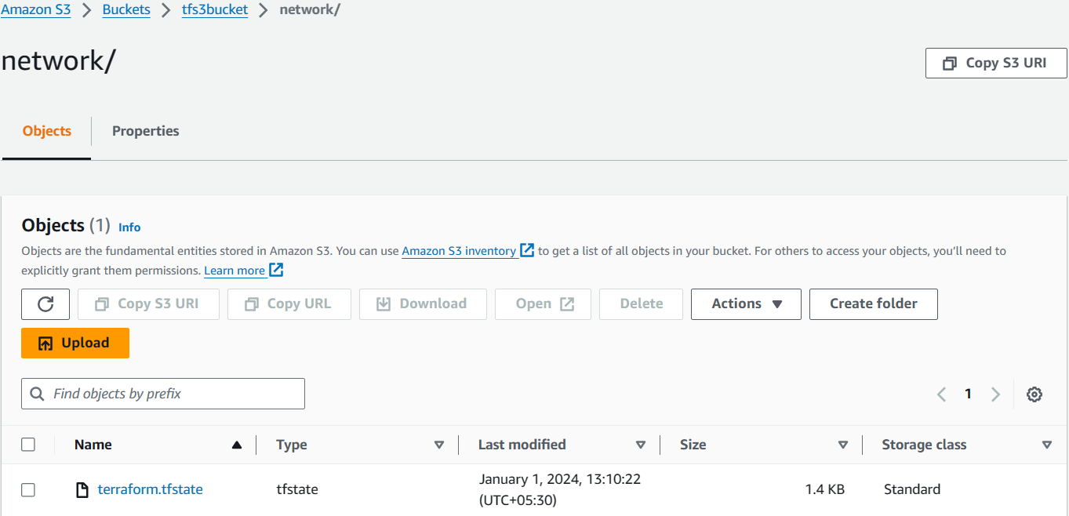
State file locking
Whenever you are performing write operation, terraform would lock the state file.
This is very important as otherwise during your ongoing terraform apply operations, if others also try for the same, it can corrupt your state file.
Eg:
Let’s assume two users are working on the same state file like creation and destroy this will corrupt the state file.
To overcome this we use state file locking. With this If a user 1 is doing some execution the state file lock will be acquired by user 1. Meantime if user2 tried to do execute something. TF will basically give an error stating that the state is locked.
To see this we are going give sleep time to resources for 300 seconds like below.
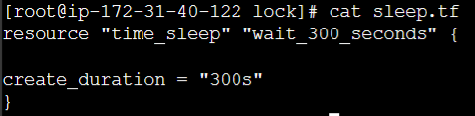
Since we set this for 300 seconds the operation will happen for 300 seconds. If another user tried to access it will show below error.
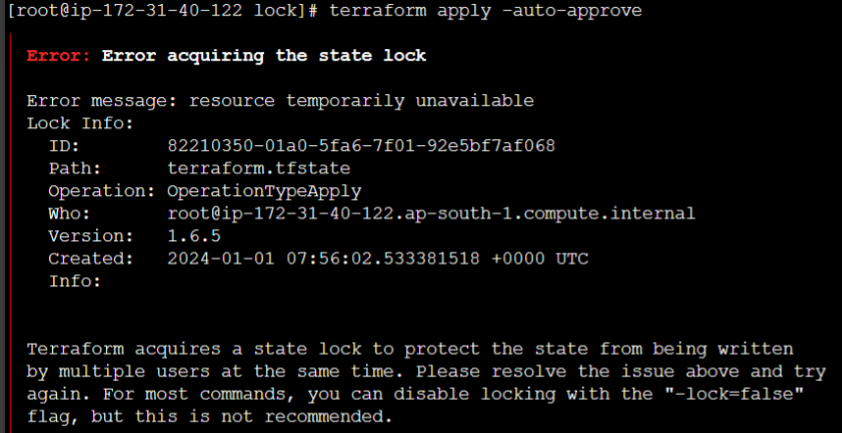
So it will perform through ‘.terraform.tfstate.lock.info” if that 300 secs is over that fill disappear automatically.
Before
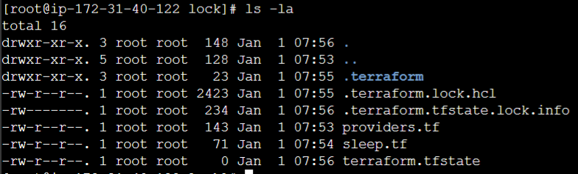
After
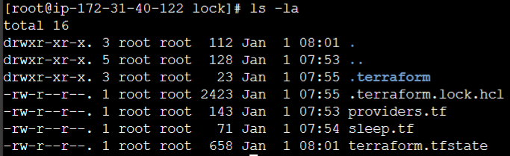
Important note:
- State locking happens automatically on all operations that could write state. You won’t see any message that it’s happening.
- If state locking fails, Terraform will not continue.
- Not all backends support locking. The documentation for each backend includes details on whether it supports locking or not.
Force unlocking state:
- TF has a “force-unlock” command to manually unlock the state if unlocking failed.
- If you unlock the state when someone else is holding the lock it could cause multiple writers.
- Force unlock should only be used to unlock when your own lock in the situation where automatic unlocking failed.
Doubts: your own lock means, is it after current ongoing operation is done but still the file is unlocked automatically?
Integrating DyanamoDB with s3 for state locking
By default, s3 does not support the state locking functionality. If you try without DynamoDB it will ignore the lock. You need to make use of DynamoDB table to achieve state locking functionality.

Terraform.tfstate s3 bucket

State Lock DynamoDB

To make use of it first we need to create DynamoDB and we need to add dyanmodb_table in code.
First to create DyanmoDB will go and search for dynamodb and we will click on it -> tables->click on ‘create table’ -> give the name as ‘terraform-state-locking’ and we need to add few things which we will get it from terraform doc.
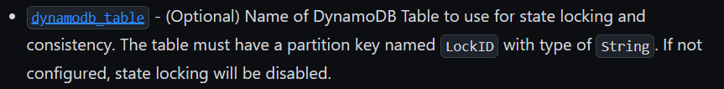
The above one we will get it from Backend Type: s3 | Terraform | HashiCorp Developer .
So while creating of DynamoDB, for partition key we will give ‘LockID’ and ‘string’ convention as given in doc.
Now we will go to code we will add ‘dynamodb_table’ .
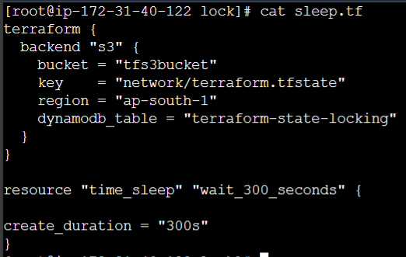
Now if you run the ‘terraform apply’ it will store the lock file in DynamoDB. Once it’s released the file will be automatically deleted.
Terraform state Management
As your terraform usage become more advanced, there are some cases where you may need to modify the Terraform state.
It is important to never modify the state file directly. Instead, make use of terraform state command.
There are multiple sub-commands that can be used with terraform state, these includes:
State sub command | Description
List | List resources within terraform state file
mv | Moves item with terraform state file
pull | Manually download and output the state from remote state
push | Manually upload a local state file to remote state
rm | Remove items from the terraform state
show | Show the attributes of a single resource in the state

List:
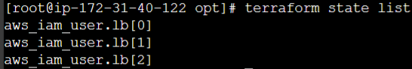
Move:
The “terraform state mv” command is used to move items in a terraform state.
This command is used in many cases in which you want to rename an existing resource without destroying and recreating it.
Due to the destructive nature of this command, this command will output a backup copy of the state prior to savings any changes

Syntax:-
Terraform state my [options] SOURCE DESTINATION
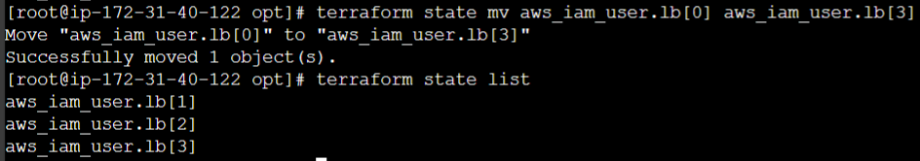
Pull:
The “terraform state pull” command is used to manually download and output the state from
Remote state.
This is useful for reading values out of state file (potentially pairing this command with something like jq)
It will pull the whole state file and show it as output.
Push:
The terraform state push command is used to manually upload a local state file to remote state. This will be used rarely.
Remove:
The terraform state rm command is used to remove items from the terraform state.
Items removed from the TF state are not physically destroyed.
Items removed from TF state are only no longer managed by TF.
Eg:
If you remove an EC2 instance from the state, the AWS instance will continue running, but terraform plan will no longer see that instance.
Show:
The “terraform state show” command is used to show the attributes of a single resource in the TF state.
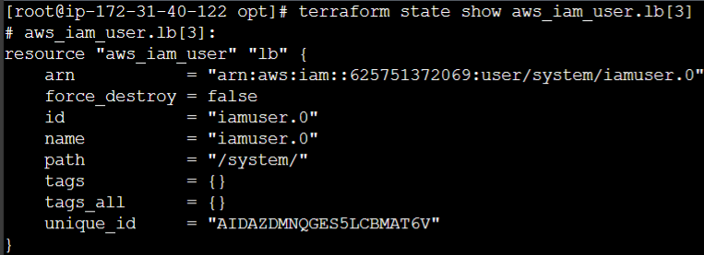
Cross-Project collaboration using terraform state

Connecting remote states:
The “terraform_remote_state” data source retrieves the root module output values from some other terraform config, using the latest state snapshot from the remote backend.
Eg: Project 1 is having some public Ips which it’s stored in state file in s3. The Project 2 wants to Fetch output values and whitelist those IPs. It will be possible with “terraform_remote_state”.
Hands on:
We have already eip state file in s3 bucket. Let’s re run it for latest state file. We will add output module.
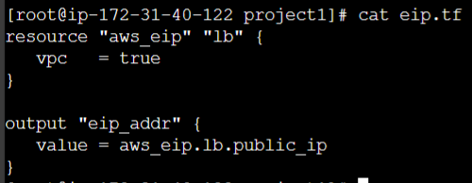
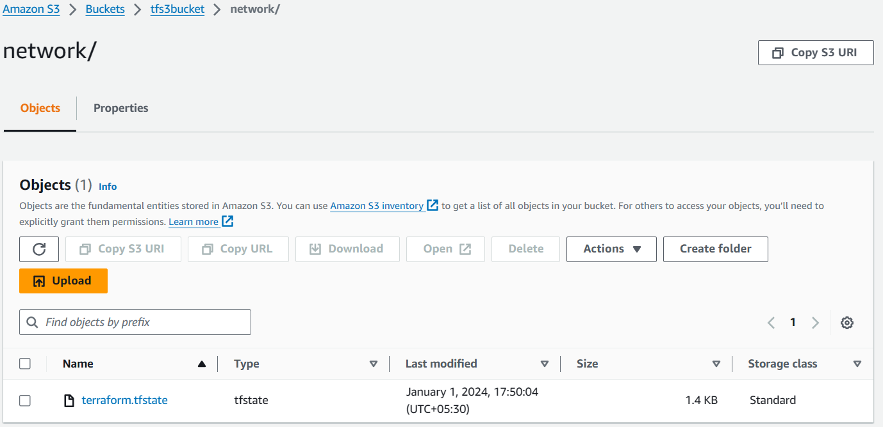
Latest state file is uploaded. Now we need tf file for security group.
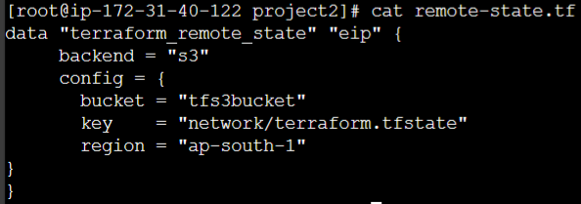
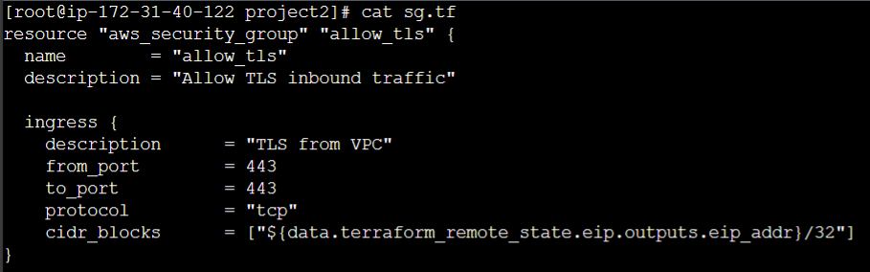
The ‘remote-state’ file script half we get through doc and half we need to add it from ‘backend’ file.
In the sg.tf
cidr_blocks = ["${data.terraform_remote_state.eip.outputs.eip_addr}/32"]
in the above script data.terraform_remote_state.eip is from ‘remote-state’ file and outputs.eip_addr is from project1 ‘eip.tf’ file.
Note: If the elastic ip gets deleted if your run for new elastic ip in project1 to update the new elastic ip in project2 we need run “terraform apply” command again.
Terraform Import
Since all of the resources are created manually, can we bring them under the purview of TF. So whatever modifications need to be done that needs to be done through TF only.
Earlier Approach in this challenge:
In the older approach, Terraform import would create the state file associated with the resources running in your environment. However actual terraform configuration file would still have to write from scratch.
Newer Approach:
In the newer approach, “terraform import” can automatically create the terraform configuration files for the resource you want to import.
So, next time onwards if you want to modify the resource or manage the resource you can modify the config file that TF has provided to you.
- Main purpose of using this is if any changes we make it manually in Dashboard of AWS, It won’t replicate it in either in configuration code file or in state file for that we use “terraform import”
Hands on:
Now I’m going to create a sg with below inbound rules in AWS Dashboard.
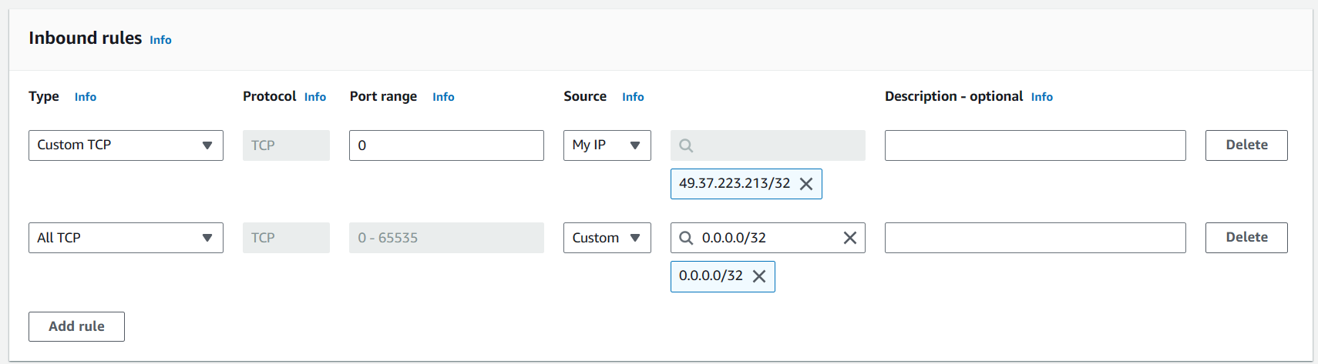
Now I’m going to import the above security group configuration script and terraform state file.
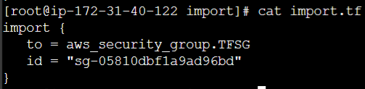
From above script, we will use ‘import’ resource. For ‘to’ we used ‘<security-group-resource-name>.<SG-name> and ‘id’ will be SG id.
But in above script instead of ‘SG name’ I have used ‘SG Tag’. But it’s working.
After writing the script we need to run this command “terraform plan -generate-config-out=generated.tf”. here generated.tf is not created but it will be created after running the command.
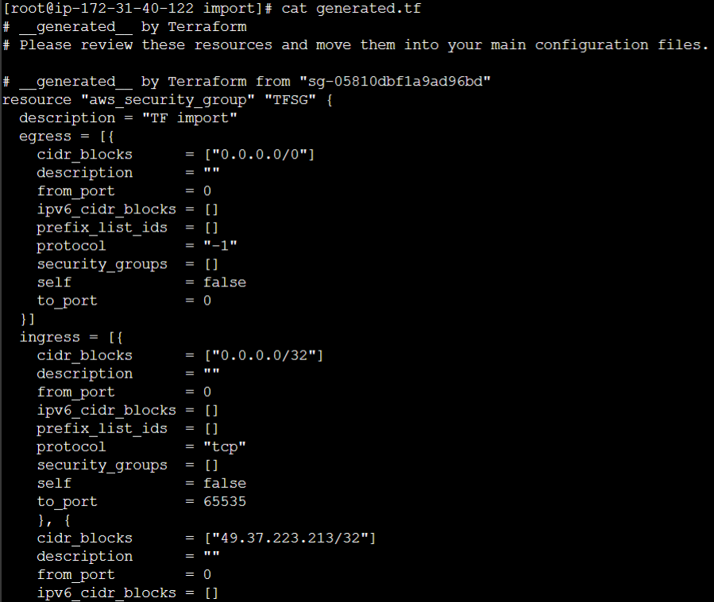
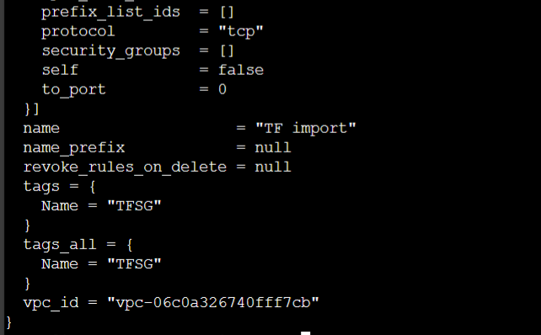
The generated file will look like this. Now we need the state file. To get the state file we need to run “terraform apply” that’s it. Now you can edit the config file that is generated.tf file and try to run it again. It will work.

